1. **Command**: ls

**Interpretation**: List contents of the current working directory

**Output**:



1. **Command**: dir

**Interpretation**: List information about the FILEs (the current directory by default).

**Output**:



1. **Command**: ls -a

**Interpretation**: List contents of the current working directory where option -a is used for displaying all the contents of the directory along with entries starting with .(dot)

**Output**:



1. **Command**: ls -l

**Interpretation**: List contents of the current working directory where option -l is used for displaying contents of the directory with a long listing format.

**Output**:

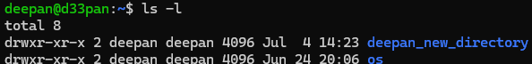

1. **Command**: ls -lh

**Interpretation**: List contents of the current working directory where option -lh is used for displaying contents of the directory with a long listing format with human understandable sizes like 1K 234M 2G etc.

**Output**:

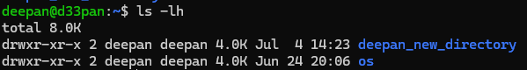

1. **Command**: ls -F

**Interpretation**: Provides a listing of files and directories in the current directory

**Output**:



1. **Command**: ls -r

**Interpretation**: List the contents of directory in the reverse order while sorting

**Output**:



1. **Command**: ls -R

**Interpretation**: List the contents of the current working directory and subdirectories recursively

**Output**:

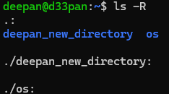

1. **Command**: ls -ltr

**Interpretation**: List the contents of the current working directory where -l displays in long listing format and -t sorts by time, (newest first) and -r reverse the order while listing recursively

So the content of the directory is listed in long listing format sorted by time(oldest first)

**Output**: 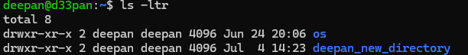

1. **Command**: ls -i

**Interpretation**: List the contents of directory with index numbers

**Output**:



1. **Command**: ls --version

**Interpretation**: Prints the version information the program ls

**Output**: 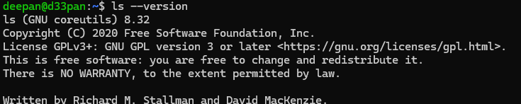

1. **Command**: ls --help

**Interpretation**: Displays the help guide of the program ls

**Output**:

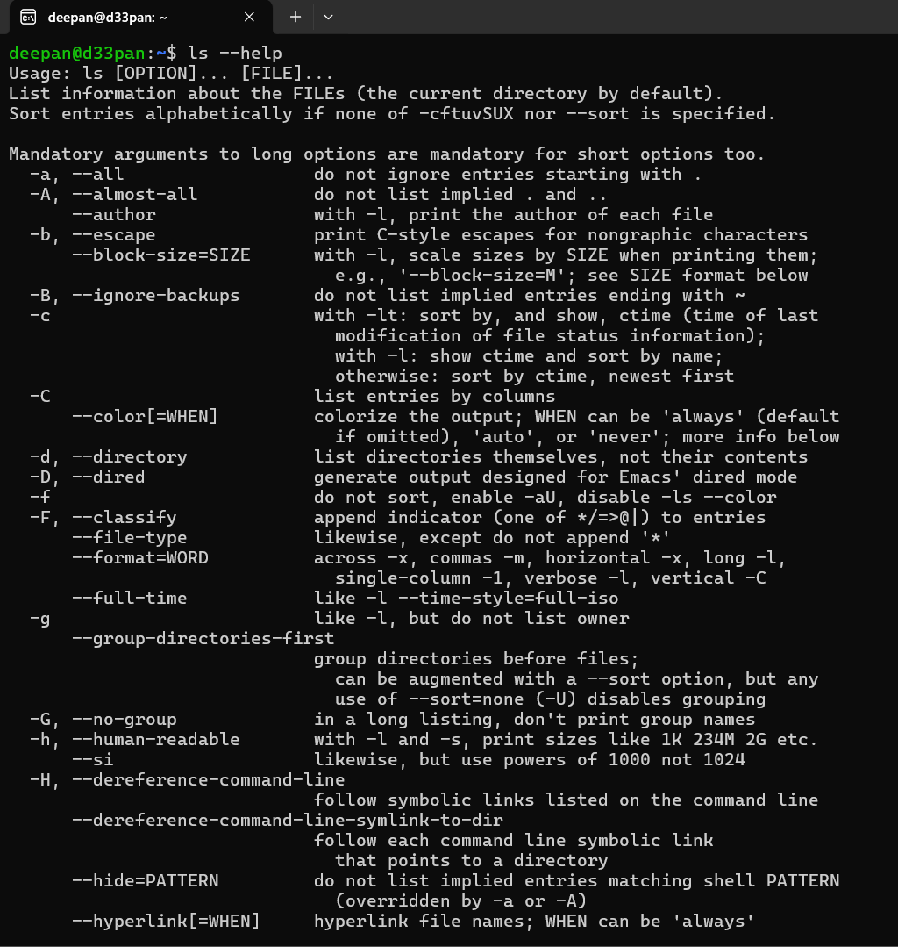

1. **Command**: ls -n

**Interpretation**: Lists the contents of directory with numeric users and group IDs

**Output**:

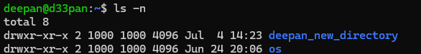

1. **Command**: clear

**Interpretation**: clear the terminal screen

**Output**:

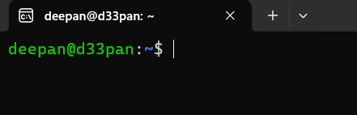

1. **Command**: mkdir os

**Interpretation**: makes directories

**Output**:



1. **Command**: ls

**Interpretation**: It is used to list the contents of the current working

directory.

**Output**:



1. **Command**: cd os

**Interpretation**: It changes directory to os in terminal.

**Output**:



1. **Command**: ls

**Interpretation**: to list contents of current working directory

**Output**:



1. **Command**: touch file_name.txt

**Interpretation**: to create a text file in current working directory

**Output**:



1. **Command**: ls

**Interpretation**: to list contents of current working directory

**Output**:



1. **Command**: nano file_name.txt

**Interpretation**: Opens the file linux.txt in text editor nano

**Output**:

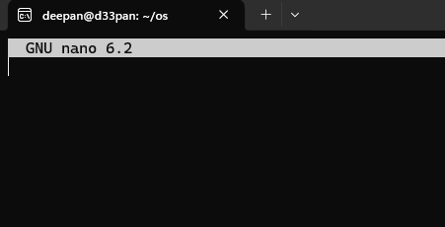

1. **Command**: cat linux.txt

**Interpretation**: Displays content of file

**Output**:



1. **Command**: touch unix.txt

**Interpretation**: Creates a file named unix.txt

**Output**:



1. **Command**: cat > unix.txt

**Interpretation**: Allows user to type as text in file unix.txt

**Output**:

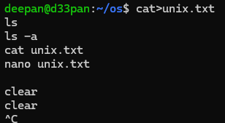

1. **Command**: cat unix.txt

**Interpretation**: Displays the content of a text file

**Output**:

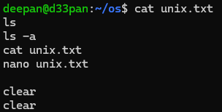

1. **Command**: touch fedora.txt arch.txt Debian.txt red_hat.txt

**Interpretation**: It creates files named fedora.txt, arch.txt, debian.txt, red_hat.txt

**Output**:



1. **Command**: ls

**Interpretation**: To list contents of current working directory

**Output**:



1. **Command**: cp linux.txt fedora.txt

**Interpretation**: Used to copy contents of linux.txt to fedora.txt

**Output**:



1. **Command**: cat fedora.txt

**Interpretation**: To display contents of fedora.txt

**Output**:



1. **Command**: cd

**Interpretation**: It allows user to change directory to one step back

**Output**:



1. **Command**: mkdir ubuntu

**Interpretation**: It creates the directory named Ubuntu

**Output**:



1. **Command**: ls

**Interpretation**: Displays contents of current working directory

**Output**:



1. **Command**: pwd

**Interpretation**: Allows user to print name of current/working directory

**Output**:



1. **Command**: cp /home/deepan/os/fedora.txt /home/deepan/ubuntu/

**Interpretation**:

**Output**:



1. **Command**: cp /home/user/Ubuntu

**Interpretation**: It lists contents of directory cp/home/deepan /ubuntu.

**Output**:



1. **Command**: cat /home/deepan /ubuntu/fedora.txt

**Interpretation**: Allows user to read the /home/deepan/ubuntu/fedora.txt and displays it

**Output**:



1. **Command**: mv /home/deepan /os/Debian.txt /home/deepan/ubuntu

**Interpretation**: It allows user to move the file from one directory to another

**Output**:



1. **Command**: cd os

**Interpretation**: Open directory named os

**Output**:



1. **Command**: ls

**Interpretation**: Displays the content of current working directory

**Output**:



1. **Command**: rm fedora.txt

**Interpretation**: Removes the file named “fedora.txt”

**Output**:



1. **Command**: ls

**Interpretation**: Displays content of current working directory

**Output**:



1. **Command**: rm arch.txt linux.txt

**Interpretation**: Removes files named “arch.txt” and “linux.txt”

**Output**:



1. **Command**: ls

**Interpretation**: Displays content of current working directory

**Output**:



1. **Command**: rm *.txt

**Interpretation**: Deletes all files whose name ends with “.txt”

**Output**:



1. **Command**: ls

**Interpretation**: Displays content of current working directory

**Output**:



1. **Command**: cd

**Interpretation**: To navigate between directories

**Output**:



1. **Command**: rmdir linux

**Interpretation**: Deletes the directory named “linux” from current working directory

**Output**:



1. **Command**: ls

**Interpretation**: Displays content of current working directory

**Output**:



1. **Command**: rmdir ubuntu

**Interpretation**: To delete directory named “ubuntu” when specified directory is empty

**Output**:



1. **Command**: ls

**Interpretation**: Displays content of current working directory

**Output**:



1. **Command**: rm -rf os

**Interpretation**: It deletes the directory “os” and it’s contents recursively and forcefully

**Output**:



1. **Command:** ls

**Interpretation:** Displays content of current working directory

**Output:**



**Conclusion**:

In conclusion, this lab exercise provides a comprehensive introduction

to fundamental Linux commands, equipping users with the skills

necessary to perform basic file and directory management tasks.

Through practical examples, users gain hands-on experience in

navigating the Linux file system, manipulating files and directories, and

using command options effectively. Mastery of these commands forms

the backbone of Linux system administration, enabling users to

efficiently interact with the operating system. This foundational

knowledge is crucial for advancing to more complex tasks and

optimizing workflow in a Linux environment. Ultimately, this exercise

serves as a stepping stone toward proficient Linux command-line usage.